Manifestations – Will the Future Design Us? At the Dutch Design Week Oct 22-30
Mental Institute for Robots?
Manifestations 2016 presents Oct 22-30 Mental Institute for Robots by Erik van der Veen in Microlab, STRP-S, Eindhoven, the Netherlands.
Manifestations, the festival that shows the future x years ahead, wonders: Will the Future Design Us? A festival with cyberpunk, privacy, innovation, digital and transdisciplinairy art and creativity for all ages. Manifestation is a production of MAD and ViolaVirus.

Getting lost in a virtual fairytale desert, a psychiatric institution for robots, Furbies with separation anxiety, exoskeletons, heat-sensors-on-your-body-so-you-can-be-used-for-mining-bitcoins, internet of women-things, implant health-trackers, Make Your Future, HyperReality, Monochrom HackerCulture, Dystopian movies, Invisible Boyfriend, Credit-dating-app, Nervous anti-terror Systems, Predictive Police, Tutorial for Terrorists… Manifestations shows the Most Innovative Developments in the world of 2016. One you can Experience and Learn to Make for Yourself! Things you’ve never seen before and will never forget. Regain Control over Your Devices. Manifestations wants to Design the Future Together, before the Future Design Us.
Read more on the website http://www.manifestations.nl and check our daily events!

Will the Future Design Us? Man is limited in observations, what happens in a world when these can be manipulated? Do we need an update in perceptions, do we need exoskeletons and other digital plugins? Are digital observation systems more absolute? In a society with Nervous Systems, our behaviour is predicted and affected. How do we regain control on our devices and systems? Will the Future Design Us or can We Design the Future?

Manifestations announces first names:
Mental Institute for Robots
Erik van der Veen - Can robots have a mental disorders?
We treat electronic devices as our slaves. Devices which have more and more complex sensors and start resembling us. The moment machines get a conscious mind, will forever change the way we treat them.
Are we still capable to understand the experiences and thoughts of machines? Can a laptop feel our fingers on her trackpad? Do Furbies develop anxiety of abandonment? Are our modems traumatised by after-images of our Bing-YouTube-sessions? Do vacuum cleaners develop bacteriophobia? What does the internet dream of?
http://www.erikvanderveen.com
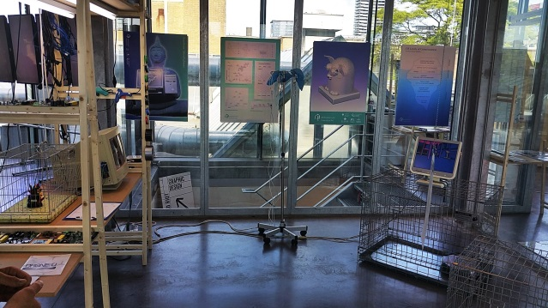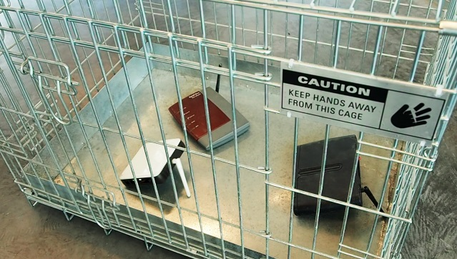
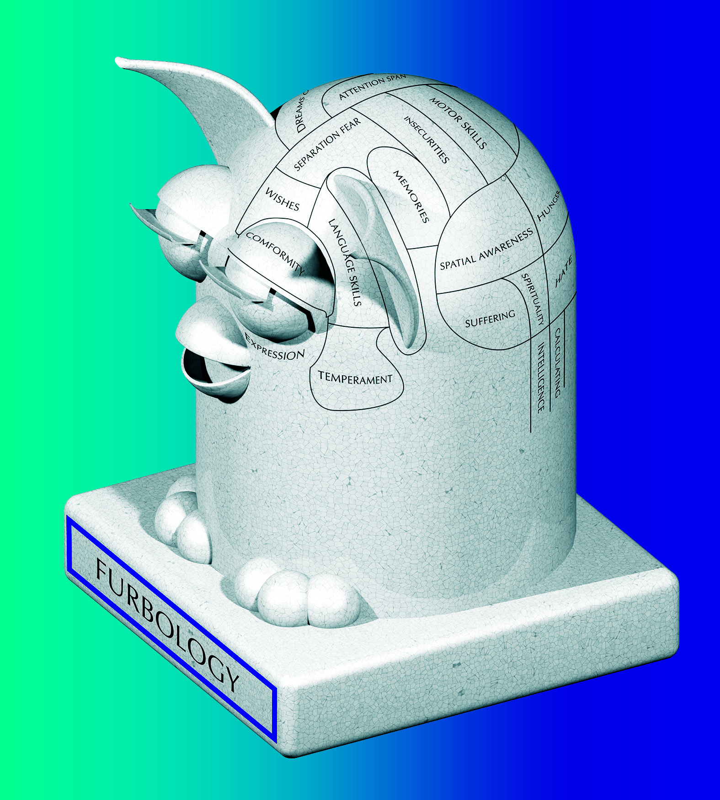

HARPER
Harper is a project about social artificial intelligence, it’s an AI with social intelligence like you never saw before, made possible by Twente University – Creative Technology. By Johannes, Evelien Nieuwenburg, Pamela Shamentaj, Yoann Latzer.
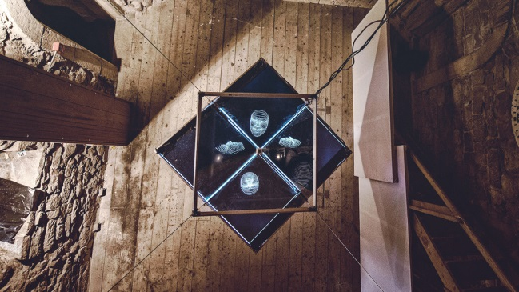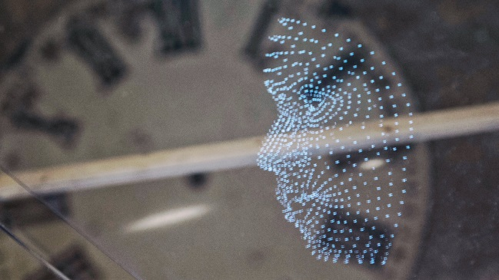
harper2016.weebly.com

Manuel Beltrán – Speculative Capital
A bodysuit which transfers our body heat into electricity, powering a Rasberry Pi, mining bitcoins?
Machines are outing us. As some time ago happened to horses after the invention of the steam engine, humans are becoming obsolete to perform manual labor, soon, with the advance of artificial intelligence, it will also affect our possibilities to be useful workers performing intellectual labor. To cope with a labor market dominated by machines we must re-adapt the position of humans in society. We present an alternative to that scenario in order to contribute and subsist in our capitalist societies.
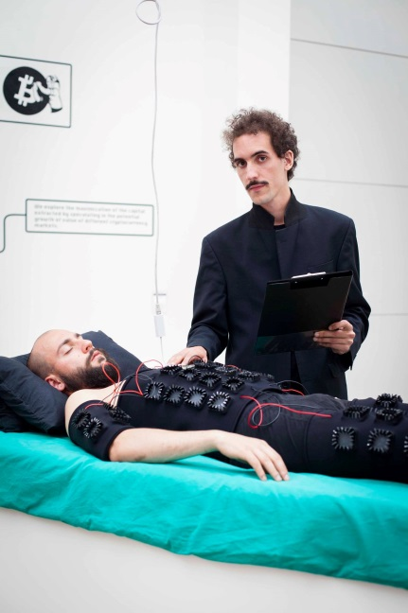
http://speculative.capital

Robin Alysha Clemens – OWNED BY NO ONE
A story about a subculture that wants to protect their visual identity in a dystopian, post-digital age. They want to rediscover their individuality in anonymity in a world where information has become a commodity and society thrives on the destruction of privacy, the id and the ego.
Awards:
‘Best Of Graduates’, Ron Mandos gallery, Amsterdam
Fotofestival Schiedam ‘Chambres de Schie’, Schiedam
Editor’s pick Life Framer ‘Open Call’
Shortlist Life Framer ‘Open Call’ (by Katherine Oktober Matthews of GUP magazine)
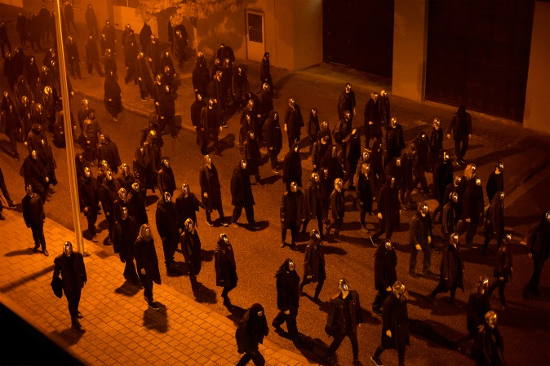

http://robinalysha.com

Leanne Wijnsma – The Smell of Data
The sense of smell helped early humans to survive. But now that our hunting and gathering has moved to the digital environment, our noses can no longer warn us of the lurking dangers in the online wilderness.
The Smell of Data is a new scent created to instinctively alert internet users of data leaks on personal devices. Smell of Data got rewarded at Science Hack Day 2016 for Most innovative project.
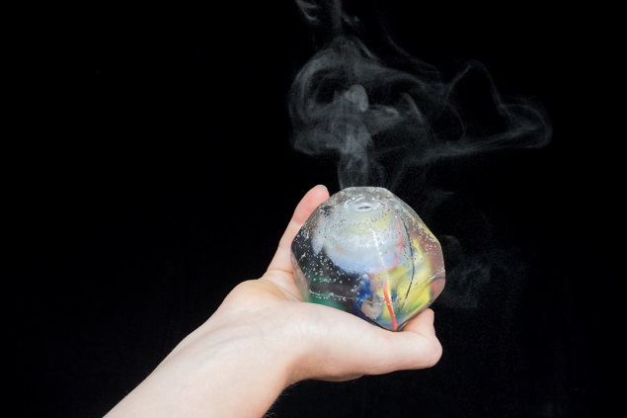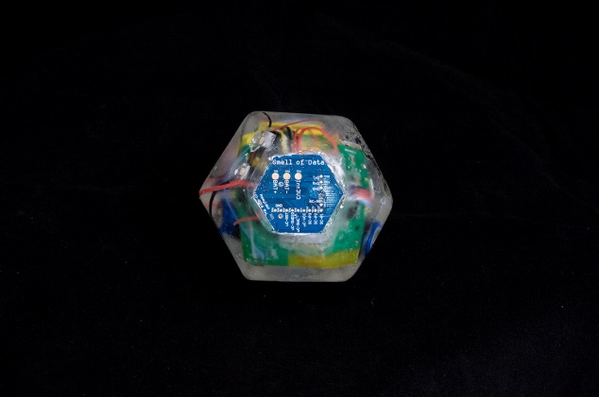
www.thesmellofdata.com

Keiichi Matsuda – Hyper-Reality
Hyper-Reality presents a provocative and kaleidoscopic new vision of the future, where physical and virtual realities have merged, and the city is saturated in media.

Cyborg Art Collective – The Ultimate Exhibition
Experience the VR exhibition with a gun controller based on the gatling gun from the game The Ultimate Doom. The Cyborg art Collective strives for art bridging the gap between science/philosophy and the general culture. Focussing on virtual reality, and autonomy of the computer program. Working within the different layers of rules and conventions, blurring the line between the control of the user and the program. Questioning the technology´s actorship and with it, its control over, and influence on our understanding of the world.
www.cyarco.com

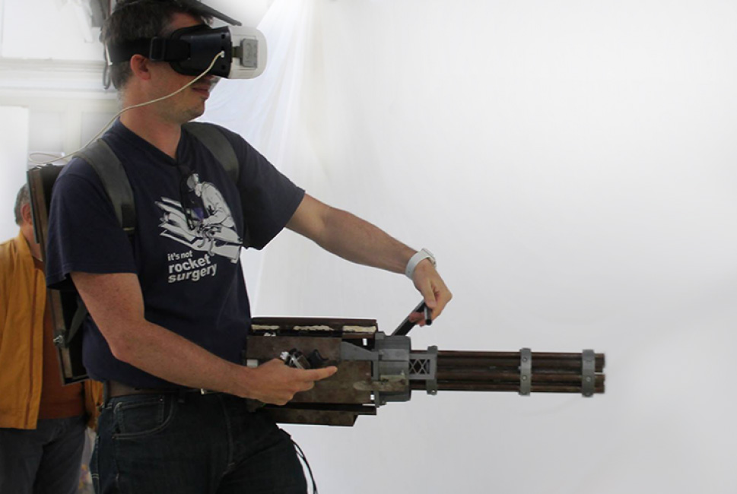

Elizaveta LEEZA Pritychenko – Welcome to the Desert of the Real
Do we perceive reality as it is? In our everyday life, we are constantly dealing with different representations of reality, where it becomes impossible to distinguish what is real, and what is not. Welcome to the Desert of the Real is a metaphorical virtual reality interpretation of Baudrillard’s concept of hyperreality, which suggests that the world we live in has been replaced by a copy world, where we seek simulated stimuli and nothing more. The Desert represents the Real, and mirages represent various kinds of so-called “simulacrums”, such as physical and psychological perceptions, media reality construct, technology and physical world, and societal conventions; and are visualised as a journey in a virtual metaphorical landscape, accompanied with an installation.

The project got nominated for KABK Graphic Design Department prize and for YoungBlood award, will be featured in BNO magazine October 8 issue.
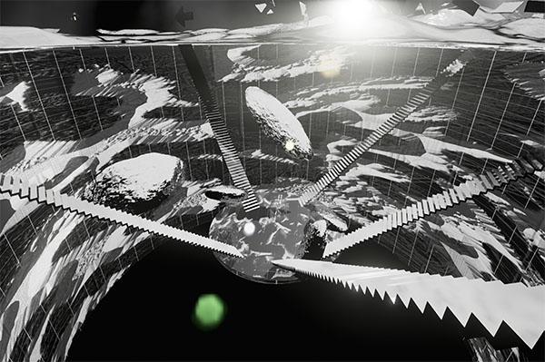
www.leeeeza.com
https://vimeo.com/161690583

Freerk Wieringa – Android / Humanoid exoskeleton
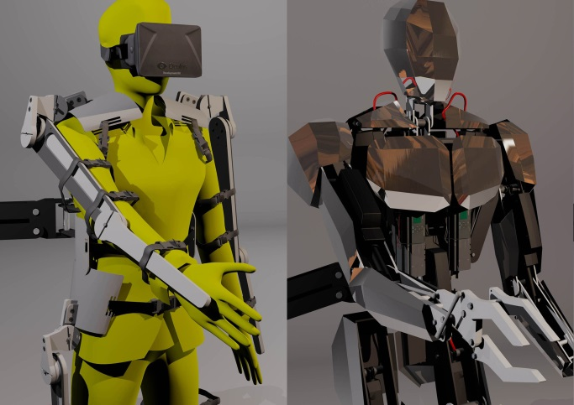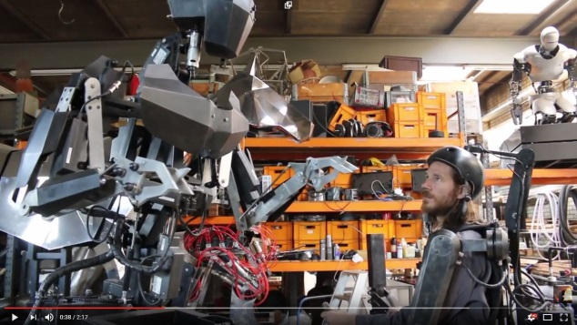
Somewhere in a laboratory in The Netherlands, a new species is born ... from steel, electronics and the human mind of artist Freerk Wieringa. The avatar came alive...
You can see and witness this at Manifestations! https://youtu.be/XFlPvajqZHo www.manifestations.nl
Oct 22-30 2016 in Eindhoven, the Netherlands
Manifestations - Will the Future Design Us?
https://youtu.be/XFlPvajqZHo (very cool video!!)

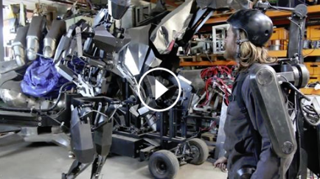

Event: Jasmina Tešanović – Internet of Women Things
Brainstorm/Hackathon event: Sunday Oct 23rd. Best works will be exhibited in 2017 at TETEM artspace and Casa Jasmina, Turin, Italy.
Jasmina Tešanović is a founder of Casa Jasmina in Turin, Italy, which shares a building with Turin’s FabLab and Arduino Office. Casa Jasmina is an experimental, open-source house space for creative, critical and arty ways of thinking, making and living in a domestic context.
In Casa Jasmina, the “Internet of Women Things” group researches how IoT devices can change the experiences of women. Currently, most IoT objects are focussed on consumer device sales (often storing or selling our private data as a business model). How can we hack this set of technologies to better engage with the reality of women’s lives?
Don’t forget to sign up, because of limited capacity. viola [ at sign] violavirus.nl
http://www.internetofwomenthings.com
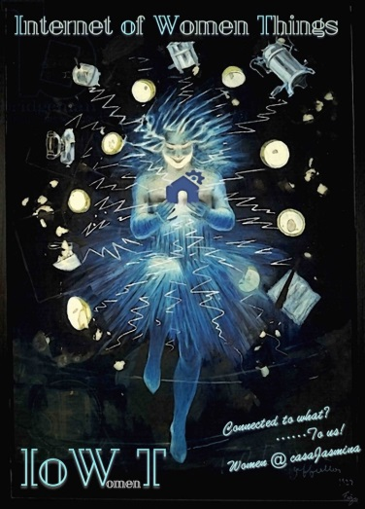

+ LOTS of daily EVENTS!! Check our Website! www.manifestations.nl

Made possible by Prins Bernhard Cultuurfonds, City of Eindhoven, Microlab

Not for publication:
// Contact: Viola van Alphen viola (apestaart) violavirus.nl 06 2090 2632
// Hi-res foto’s: http://www.manifestations.nl/wp-content/pers/Manifestations.zip – 100MB (updates regularly). Right mouse click: Save As..
// videos:
Erik van der Veen: Metal Modems: https://vimeo.com/173184215
Leeeza: Welcome to the Desert of the Real: https://vimeo.com/161690583
Keiichi Matsuda: Hyper-Reality: https://vimeo.com/166807261
Giulia Tomasello: Future Flora: https://vimeo.com/171795174
Monochrom: TraceRoute: https://vimeo.com/147111732
Freerk Wieringa: Humanoid/Android exoskeleton: https://www.youtube.com/watch?v=XFlPvajqZHo

